An Awareness Programme on Health and Hygiene

In the month of February, the Women Cell Committee organised an awareness programme on Health and hygiene. This programme was held from 1/2/22 to 3/2/22. Dr. Jasmina Sarda, the coordinator of the Women Cell Committee welcomed all the Women Cell members. All gathered faculty members shared their views about the safety and hygiene among the girls. Smt. Hansaben Gujariya compèred the whole awareness programme .The whole event was successfully conducted with a vote of thanks from Dr. Krishna Daiya. After the wonderful and fruitful sessions, sanitary pads were distributed among the girls and these pads were made available in the girl’s washroom.

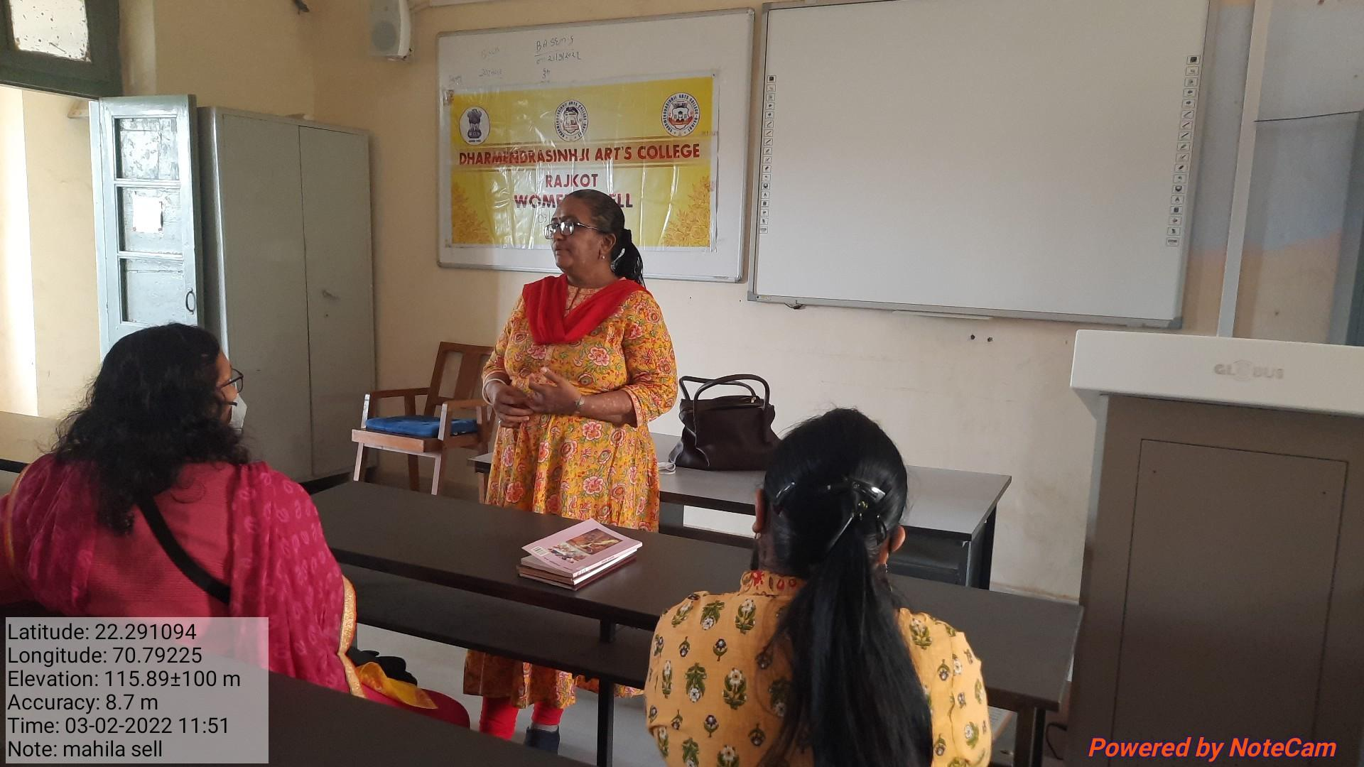
Dr. Jasmina Sarda, the coordinator of the Women Cell Committee

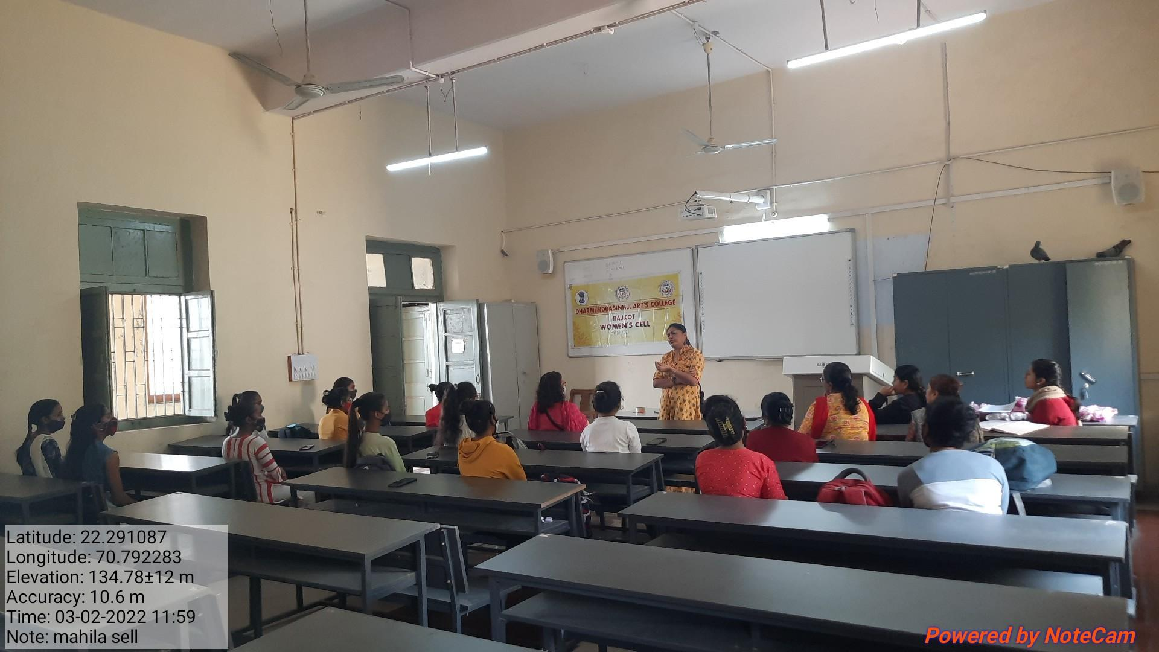
Dr. J.J. Vyas on Health and Hygiene
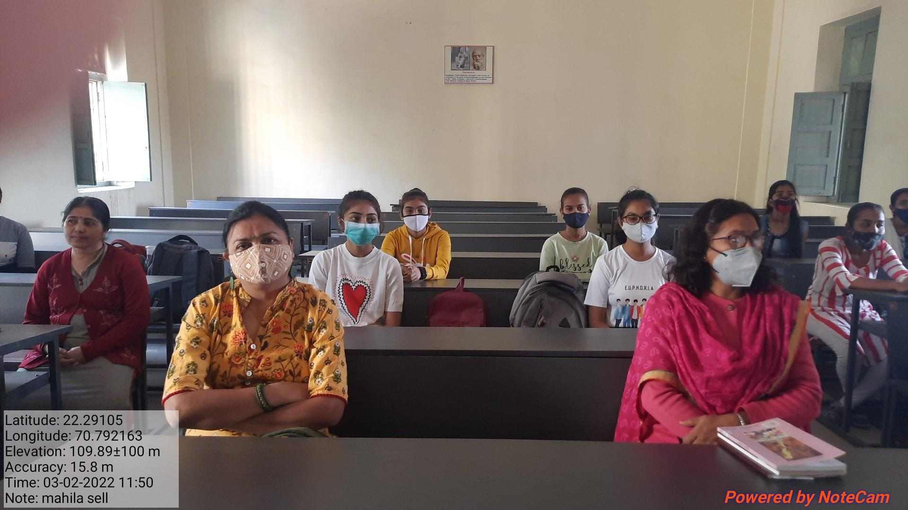
Participants of the programme

